The Cromwell Association 2017 Study Day – Saturday 7th October 2017
Cromwell and Europe
As the United Kingdom prepares to disengage with the European Union, what was happening in Europe during the English civil wars, the Commonwealth and Protectorate? Did Cromwell want to engage with Europe or was he an isolationist? This Study Day, with five contributions on different aspects of the theme, will provide context for, and at times perhaps surprising details of, Cromwell’s views on Europe.
Programme
10.30 Registration and coffee
11.00 Welcome and introduction. Professor Peter Gaunt, University of Chester, and President of the Cromwell Association.

11.10 Understanding the Thirty Years War
Peter H. Wilson, Chichele Professor of the History of War at the University of Oxford
The Thirty Years War was the most destructive conflict in European history prior to the two twentieth-century world wars. It has variously been presented as the last and greatest of an age of religious wars, or as the culmination of a struggle over potential Spanish hegemony across Europe. In this paper, Peter Wilson argues that most attempts to explain the war confuse rather than clarify what it was actually about. Contemporaries recognised the Thirty Years War as a distinct struggle over the religious and political order in the Holy Roman Empire that began with the Defenestration of Prague in May 1618 and ended in the Peace of Westphalia in October 1648. The paper will explain the causes, outline the conduct, and examine how and why peace was finally made.

Peter H. Wilson is Chichele Professor of the History of War at the University of Oxford and a Fellow of All Souls College. He worked previously at the universities of Hull, Newcastle and Sunderland, and has been a visiting fellow at the University of Münster in Germany. His publications include The Holy Roman Empire: A Thousand Years of Europe’s History (2016) and Europe’s Tragedy: A History of the Thirty Years War (2009) which won the Society for Military History’s Distinguished Book Award. His latest book, Lützen 1632, will be published later in January 2018 by Oxford University Press.

12.00 Consistency and contrast in Cromwell’s policy towards Europe
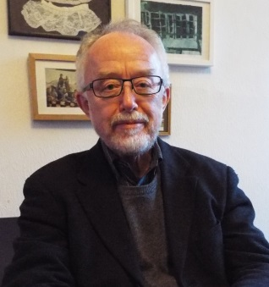
Hugh Dunthorne , History Department at Swansea University, (retired 2009).
From the Western Design to the wars in the Baltic, the foreign policy of Cromwell and the English Council of State ranged widely and made a profound impression on contemporaries at home and abroad. Taking their views into account as well as the views of modern historians, this talk will consider the basic aims of Cromwell’s policy while also trying to explain its contrasts. Towards the Dutch and Scandinavian states the Protector acted with caution and restraint, whereas in dealing with France and Spain he was more ambitious and aggressive.
Hugh Dunthorne taught in the History Department at Swansea University until his retirement in 2009. His most recent book is Britain and the Dutch Revolt 1560-1700 (2013) and he has also edited, with Michael Wintle, The Historical Imagination in nineteenth-century Britain and the Netherlands (2013). He is now working on a study of war artists from the sixteenth century to the twentieth.
Lunch
13.35 Cromwell’s intervention in 1655 to halt the Confessional Cleansing of Milton’s “Slaughtered Saints; in Piedmont.

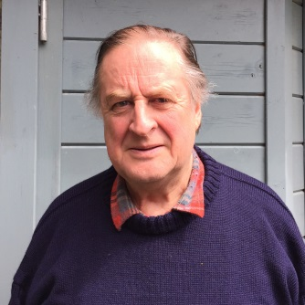
Richard Newbury, journalist and member of the Waldensian Church
Avenge, O Lord, thy slaughtered saints, whose bones
Lie scattered on the Alpine mountains cold;
E’en them, who kept thy faith so pure of old,
When all our Fathers worship’d Stocks and Stones,
Forget not: in thy book record their groans,
Who are thy Sheep, and in their ancient Fold
Slain by the bloody Piedmontese, that roll’d
Mother and Infant down the rocks.
How and why did Cromwell intervene to support the Protestant sect mostly remembered now by Milton’s lines?
Richard Newbury MA Cantab is a commentator and feature writer for the Italian press [Il Foglio, Il Corriere della Sera and La Stampa] as as well as on national broadcasters [RAI, Sky, La 7 and Swiss TV]. He is the author in Italian of a dozen biographies of significant British figures the most recent of which is Oliver Cromwell. He is a Committee Member of the Waldensian Church Missions and divides his time between Cambridge and Torre Pellice in the Waldensian Valleys

14.15 Reform, Republicanism and Refuge: Anglo-Swiss relations in the mid-seventeenth century
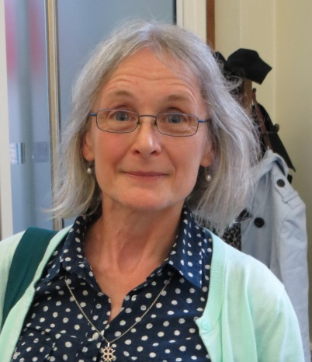
Vivienne Larminie, Senior Research Fellow, History of Parliament Trust

Links with the Swiss Confederation are a relatively neglected aspect of relations between the British Isles and other European powers in the seventeenth century. The few moderately familiar examples of interaction in the 1650s – the ecumenical embassy of John Durie (not just to Switzerland); the Confederation’s efforts at mediation in the Anglo-Dutch war; fund-raising for the persecuted Waldensians (not strictly Swiss) – appear to come almost from nowhere. But they did not. Academic and religious interchange, a traffic in books, commercial links, travel and diplomacy were well-established. English puritan writing influenced early Swiss pietism, while the oligarchic republics presented a model of Protestant states (economically ascendant within the federation) directing their own political affairs and dominating their churches, while co-existing with their Catholic neighbours. The Restoration exile of the regicides rested on and revealed this prior engagement; the experience of refuge coloured Edmund Ludlowe’s memoirs of the commonwealth and protectorate.
Vivienne Larminie joined the History of Parliament Trust from the Oxford Dictionary of National Biography, where she was a research editor for the 17th century, and wrote over 100 articles. She has researched Wiltshire and Oxfordshire MPs for the HoP and complementary projects include Oxford 1630–1686 and the French church at Westminster. She maintains a longstanding interest in Anglo-Swiss relations and in the Pays de Vaud, Switzerland, from the reformation to the revolution of 1798. Other publications include; ‘Exile, integration and European perspectives: Huguenots in the Pays de Vaud’, in D. J. B. Trim ed., The Huguenots: History and Memory in Transnational Context (Brill: Leiden and Boston, 2011); ‘The Jacobean diplomatic fraternity and the protestant cause: Sir Isaac Wake and the view from Savoy’, English Historical Review cxxi (2006); ‘Oxford DNB, the du Moulin connection and the location of the Church of England in the later seventeenth century’ in A. Dunan-Page ed., The Religious Experience of the Huguenots, 1660–1750 (Ashgate, 2006); ‘La vie religieuse en pays de Vaud et le contexte européen’ in F. Flouck, P.-R Monbaron, M. Stubenvoll and D. Tosato-Rigo eds., De L’Ours à la Cocarde: régime bernois et révolution en pays de Vaud (1536-1798) (Payot: Lausanne, 1998); Wealth, Kinship and Culture: the seventeenth century Newdigates of Arbury and their world (Boydell and Brewer for Royal Historical Society, 1995).

15.00 ‘Permanent and inviolable’: Oliver Cromwell and the idea of Anglo-Dutch Union in 1653
Jason Peacey, Professor of Early Modern British History at UCL
Historians of international relations are apt to focus on warfare and peacemaking rather than on cooperation between states, and historians of the seventeenth century have been apt to focus on tensions between England and the Dutch Republic rather than on the possibility for their working together in harmony, at least if this meant anything more than strategic alliances which aimed – in the years following the peace of Westphalia – at countering the threat from powerful neighbours and achieving a ‘balance of power’. It has been too easy, therefore, to concentrate upon Anglo-Dutch conflict in the early 1650s, and on the debate about whether this stemmed from economic competition or apocalyptical republicanism. This paper seeks to focus instead on Cromwell’s ideas about, and proposals for, an Anglo-Dutch union in 1653, not least in a context in which a growing number of English commentators looked admiringly at Dutch economic, political and religious culture.

Jason Peacey is Professor of Early Modern British History at UCL. He edited The Regicides and the Execution of Charles I (2001) and The Print Culture of Parliament, 1600-1800 (2007), and co-editod Parliament at Work (2002), and is the author of Politicians and Pamphleteers. Propaganda in the Civil Wars and Interregnum (2004), and Print and Public Politics in the English Revolution (2013). He is currently researching overlapping and interlocking publics in seventeenth century Europe.

15.45 Discussion and conclusions

16.00 Finish

